Name – Kamal D. Agrahari Subject – DevOps Lab

ID -VU4F2223028 TE IT A | Batch B

**Experiment No. 2**

**Aim** - Study of Version Control System/Source Code Management, install git and create a GitHub Account.

**Theory** –

Version Control:

Version control is a system that manages changes to a project’s files and directories over time. It allows multiple people to work on a project simultaneously, tracks history, and facilitates collaboration. Key features include:

1. Tracking Changes: Records modifications to files, making it possible to revert to previous versions if necessary.
2. Collaboration: Multiple contributors can work on the same project simultaneously without overwriting each other's work.
3. Branching and Merging: Facilitates experimentation by allowing users to create branches (copies of the project) and later merge changes back into the main branch.
4. Backup and Restore: Provides a backup of all versions of a project, making it easier to recover from data loss or corruption.
5. Code Review: Helps in peer reviewing code changes before integrating them into the main codebase.

Popular version control systems include Git, Subversion (SVN), and Mercurial.

Steps for Installing of Git

1. Go to the gitforwindows.org website then click on the DOWNLOAD button to download the installer

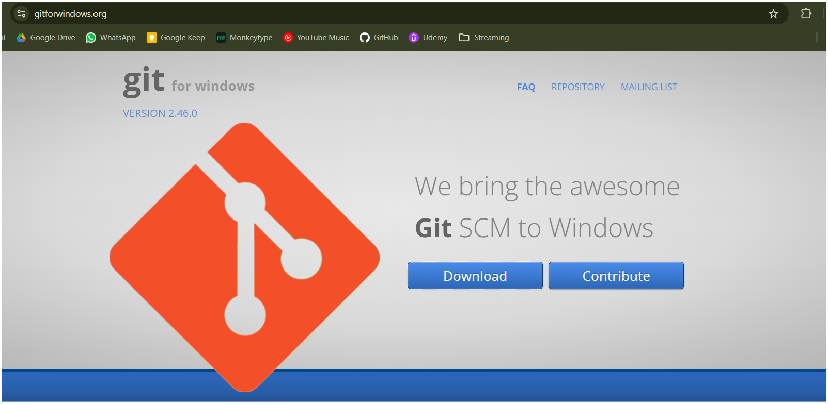

2. Run the installer and go throught the setup to install the git on your computer. It may ask some permissions click YES to allow the installer to run

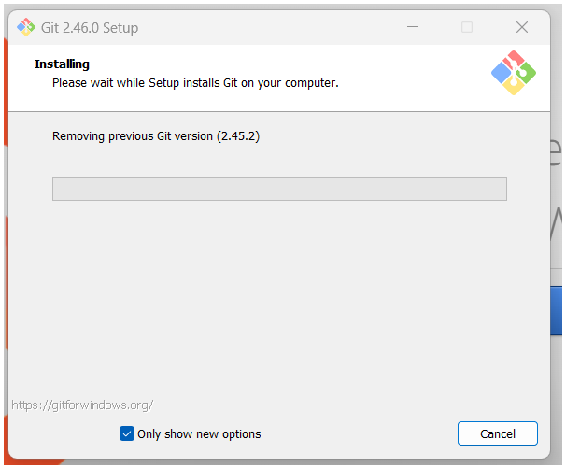

3. See if git bash is installed, type command git –version to verify the installation

